Application for patent filing
Date | D | D | M | M | Y | Y | Y | Y
 | 2 | 8 | 0 | 4 | 2 | 0 | 2 | 5

Name of the Faculty | : | Dr Sumathy G
Department | : | Computational Intelligence (CINTEL)
Faculty ID Number | : | 102946
Official E-mail ID | :
Contact no. of all Inventors |  | 9456179625, 8148473998
Major area of invention | : | Artificial Intelligence, Career Guidance Systems
Narrow focus area of invention | : | Data-driven Personalized Career Assistance using Socio-economic, Behavioral, and Mentorship Analysis
Title of the invention |  | Visionary Career Assistance: A Data-Driven Personalized Career Guidance Platform
Earlier status of research | : | Career guidance systems exist but primarily focus on aptitude tests or course recommendations. Few integrate behavioral tracking, income analysis, and mentor connections holistically.
How different your invention from similar research / others - Novelty? | : | The platform uniquely combines behavioral pattern tracking, socio-economic background analysis, and mentor matching using dynamic data visualization and real-time updates. It offers personalized career mapping and mentor connectivity, addressing underrepresented communities' needs.
Possible domain for field application | : | Education, Career Development, Human Resource Counseling, E-learning Platforms
Possible sector for commercialization | : | Educational Institutions, Career Guidance Firms, EdTech Companies, Government Educational Schemes
Faculty Signature with date | :

Invention Disclosure Form
To be filled by the inventors
Please provide highly relevant information for details asked below and use consistent language while describing the specific feature or element in the invention disclosure.
1. | Title of invention: Visionary Career Assistance: A Data-Driven Personalized Career Guidance Platform
2. | Describe the invention.  The invention is a software platform combining interactive dashboards and a mentorship connection system. It analyses students' socio-economic factors, behavioural trends, and role model impacts to deliver tailored career insights. It integrates frontend (React/TypeScript) with backend (Node.js/PostgreSQL) and real-time event processing.
3. | Does the invention provide a new use of or improvement to an existing product or process?  It improves existing career guidance methods by incorporating dynamic behavioural tracking, income influence analysis, and automated mentor matching.
4. | State the Novelty of the invention and specify the claims in the invention  - Real-time career factor visualization.  - Income-based opportunity mapping.  - Automated mentor-student matching algorithm.  - Integrated behavioural tracking affecting career decisions.
5. | Describe the advantages of the present invention over the existing technologies  - Dynamic personalization.  - Mobile-friendly and inclusive design.  - Real-time feedback and analysis.  - High scalability for mass deployment.
6. | Describe how the present invention overcomes the drawbacks of currently available technology related to your invention.  Traditional systems ignore individual behavioural evolution and socio-economic barriers. Our system captures real-time behaviour trends and economic influences, offering a much more holistic career guidance framework.
7. | Describe uses, applications and benefits of the invention.  - Used by schools, colleges, and career counselors.  - Assists economically disadvantaged students.  - Provides continuous mentorship opportunities.  - Improves career decision-making confidence.
8. | Does the focus of the invention results in societal impact technology?  Yes. Promotes equitable access to career guidance, bridges educational gaps, and addresses the Sustainable Development Goals (SDG 4 and SDG 8).
9. | Characterize the disadvantages and limitations of the invention  - Depends on accurate self-reporting by users.  - Relies on internet connectivity.  - Continuous updating of mentors and datasets needed.
10. | Enclose the sketches, drawings, photographs and other materials that help in better understating/ illustration of the novelty in the invention.  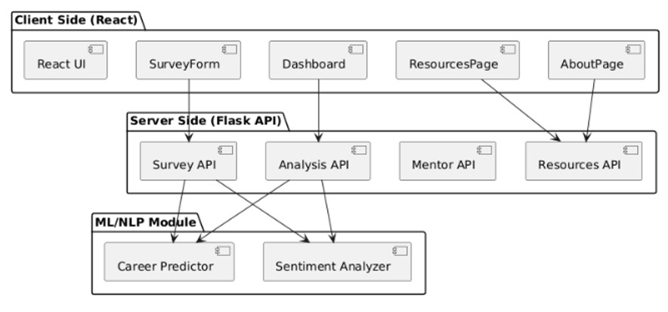
11  . | Current development status of the invention  - Prototype tested successfully.  - Experimental approach included beta testing with 500 students.  - Data documented through surveys and user feedback.  - Further enhancements in mentor expansion and machine learning prediction modules are planned.
12. | Please list any of your publications

13. INVENTOR(S) AND/OR CONTRIBUTOR(S):
 | INVENTOR (1) |  | INVENTOR (2)
Signature:
Name: | Atharv Dobhal |  | Hari Venkataraman
Address: | Department , SRM IST, Kattankulathur campus-603203 |  | Department , SRM IST, Kattankulathur campus-603203
City and State: | Chennai &Tamil Nadu |  | Chennai &Tamil Nadu
Citizenship  (Country): | INDIAN |  | AMERICAN

14. ASSIGNMENT DETAILS: Assignee is the entity or individual who holds the patent.
Signature: (To be signed by the authorized signatory on behalf of the assignee)
Name of the Authorized Signatory and Designation
Address:
City and State:
Citizenship
(Country):

